**Return Differences between Trading and Non-trading Hours:**

**Like Night and Day**

The returns during the night are strongly positive, and returns during the day are close to zero and sometimes negative. This day and night effect holds for individual stocks, equity indexes, and futures contracts on equity indexes and is robust across the NYSE and Nasdaq exchanges. Night returns are consistently higher than day returns across days of the week, days of the month, and months of the year. The effect is driven in part by high opening prices which subsequently decline in the first hour of trading.

In a broad sense, many of the models developed in the aforementioned theory papers predict lower returns over nontrading periods than trading periods.The equity premium in the adjacent open to close (daytime) period is zero or even negative, a puzzling finding that implies no reward for bearing risk in daytime volatility. Specifically, for the individual stocks in the S&P 500 index from 1993 to 2006,

In this paper, we document a surprising new pattern in returns; night returns, measured from close to open, are greater than day returns, measured from open to close. This pattern in 24 returns produces the unexpected finding that the US equity premium (as measured by the S&P 500) over the last decade is solely due to overnight returns. To a certain extent, some degree of positive overnight returns can be expected due to an illiquidity premium as suggested in the model developed by Longstaff (1995). However, our evidence on day time returns is puzzling because it suggests a zero or negative risk premium during trading hours when the rate of information flow and volatility are much higher compared to overnight periods.

3.1. Day and Night Returns We start our analysis of by providing a visual perspective of the differences between day and night returns. In Figure 1 we plot the growth of a $1 investment in trade-price based night returns and the growth of a $1 investment in trade-price based day returns from February 1993 to December 2006 in the S&P 500 Spider (SPY) exchange traded fund. We do not include 11 Relative to standard errors from OLS estimations, the clustered standard errors we use are on average, for many of our tests, much larger (about a factor of 7 for the S&P500 stock sample), suggesting that our results are quite conservative relative to OLS standard errors. 10 transaction costs. The figure suggests that night returns are greater than day returns. The $1 investment grows to $6.54 for night returns and decreases to $0.61 for day returns over 14 years.

In a previous study, by several quant researchers it was found that the returns across various asset classes during the night are strongly positive and returns during the day are close to zero and sometimes negative. This day and night effect holds for individual stocks, equity indexes, and futures contracts on equity indexes and is robust across the NYSE and Nasdaq exchanges. Night returns are consistently higher than day returns across days of the week, days of the month, and months of the year. The effect is driven in part by high opening prices which subsequently decline in the first hour of trading.

A reference to the above premise can be found at <http://ssrn.com/abstract=1004081>

There is enough evidence that the above theory works because the opening and closing of markets have an effect on short-term price movements, trading volume, and volatility.

In this article, we will explore the returns delivered by Amazon and Apple Inc while following the Night and Day Trading strategy and show you the Python implementation of it.The Day and Night Strategy is based on the theory that major movements in stock prices happen overnight as compared to during trading hours.

Also, we will code another strategy which is based on a trading based on Gap-Open and compare the returns. In a Gap-Open trade, we go long when today’s Open is above than Previous Close and exit on Day’s close. Also, we go short when today’s Open is below the Previous Close and exit the trade at the end of the day.

**Instructions to develop the strategy:**

The following are the steps involved in executing the overnight strategy:

**Step 1**: First we will import the necessary modules for this code. The modules used are:

1. Pandas: for creating data frames
2. Yfinance: for accessing stock data
3. Datetime: for accessing date and time
4. matplotlib.pyplot: for plotting graphs

To install these modules on your system use the pip installer.

Now import the modules.

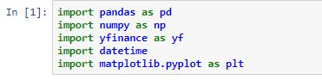

**Step 2**: Now we have to give the Start date and End date.

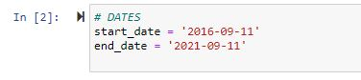

**Step 3**: We will download the stock data of Amazon and AAPL from the date of investment to the current date. To download data we use:

yf.download(ticker, start_date, end_date) where ticker is the symbol of stock for Amazon it is AMZN and for Apple it is AAPL.

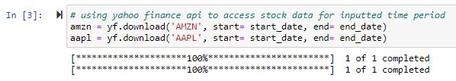

**Step 4**: Cleaning the data. For this strategy, we only require the open and close price of the stocks. So we will remove all the other columns.

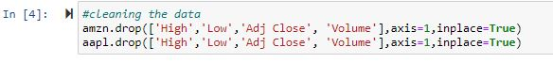

**Step 5**: Now we will calculate the overnight return for each day. The logic for calculating overnight return is to subtract the open price of the day with the closing price of the previous day. So it is:

(Open — Prev. Close)/Prev.Close

we will also calculate the day return for each day. The logic for calculating day return is to subtract the open price of the day with the closing price of that day. So it is:

(Open – Close)/Open

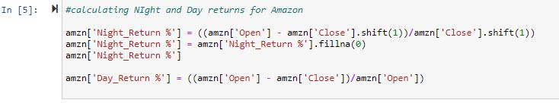

**Step 6**: The next step is to actually code the positions we would open by following our strategy. Because we are only looking at the past, we can easily do so in Pandas with simple data wrangling. We encode a long position using 1 and a short one with -1. This will simplify calculating the strategy’s returns.

We drop the NaNs, which can be introduced because:

* there is no previous price, which is the case for the first observation
* the previous day’s close is equal to the current day’s open. For this dataset, it did happen a few times.

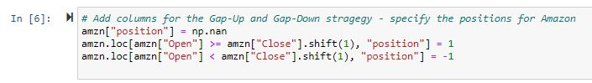

**Step 7**: We have the positions, now we need to see how much we would profit by following such a strategy. To do so, we calculate the intraday returns by looking at the difference between the open and close prices. Then, we multiply the returns by the position. Lastly, we calculate the cumulative returns.

In the end, the gap strategy generated a return of ~220%. Quite an achievement, however, we need to be aware of the fact that past performance of the strategy is no indication of the future performance.

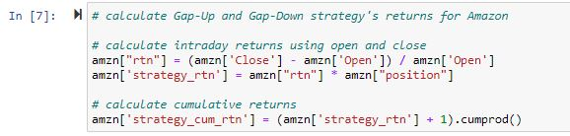

**Step 8**: let’s also have a look at the simple **buy-and-hold strategy**. We buy the asset on the first day (for the closing price) and hold it until the end of the period of interest.

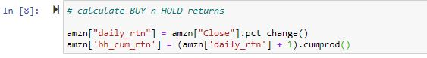

**Step 9:**

